PHASE 1 OF 8
Brainstorming & Ideation Phase
Auto Ticket Classification using Flow Designer

Project | Platform | Team members
Auto Ticket Classification using Flow Designer | ServiceNow (Flow Designer) | SAMRIN HASRAA S  SALMA FARHANA M  SAJITHA FATHIMA S K  FATHIMA M

1. Problem Statement
The school IT helpdesk receives many incident requests every day from students and teachers – Wi-Fi issues, projector failures, password problems and slow computers. IT staff currently open each ticket, read it and manually choose the Category and Subcategory. This is:
- Time-consuming – every ticket needs a human touch before work can start.
- Error-prone – different staff pick different categories for the same issue.
- Not scalable – more requests means more manual effort.

2. Objective
- Automatically classify incidents at the time of creation.
- Reduce manual effort for IT agents.
- Improve ticket routing efficiency.
- Deliver a no-code, easily maintainable solution.

3. Stakeholders
Stakeholder | Role | What they need
Student / Teacher | Ticket creator (Caller) | Raise a ticket quickly with only a short description and receive confirmation
IT Agent | Ticket resolver | Tickets that are already categorised so work can start immediately
IT Head / Admin | Process owner | Consistent data, easy maintenance, ability to add new rules

4. Empathy Map
 | Student / Teacher (Caller) | IT Agent
Thinks | "Did my request reach IT?" | "I spend half my time just sorting tickets."
Feels | Anxious when there is no acknowledgement | Overloaded by repetitive work
Says | "My Wi-Fi is not working in the library." | "This ticket is in the wrong category again."
Does | Types a short description and submits | Reads each ticket and picks category manually
Pain | No confirmation, unclear status | Delays and misrouted tickets
Gain | Instant acknowledgement | A clean, pre-classified queue

5. Brainstormed Ideas
# | Idea | No-code? | Effort | Maintainability
1 | Agent classifies every ticket manually (current process) | – | High, recurring | Inconsistent results
2 | Business Rule with server-side script | No | Medium | Needs a developer
3 | Predictive Intelligence / ML classification | Partly | High (needs training data) | Complex, overkill for a small setup
4 | Virtual Agent asks user to choose category | Yes | Medium | Extra step for the user
5 | Flow Designer with keyword rules on Short Description | Yes | Low | Easy – admin edits conditions

6. Idea Selection
Selected: Idea 5 – Flow Designer keyword-based auto classification.
- Completely no-code, so any admin can maintain it.
- The school's issues fall into a small set of well-known types, so keyword matching is enough.
- Works immediately when a record is created – no waiting for an agent.
- Easy to extend by adding one more *Else If* branch.

7. Proposed Solution
- Create a custom table Incident Workflow with Caller, Category, Subcategory, Short Description, State, Assigned Group and Assigned to.
- Make Subcategory depend on Category so only valid combinations exist.
- Build the flow Auto Classify School IT Tickets that triggers on *Record Created* when *Category is empty*.
- Inside the flow, check Short Description for keywords and Update Record with Category and Subcategory.
- Send Email to the caller confirming the ticket was submitted.
- Package everything in the Project Update Set so it can move to another instance.
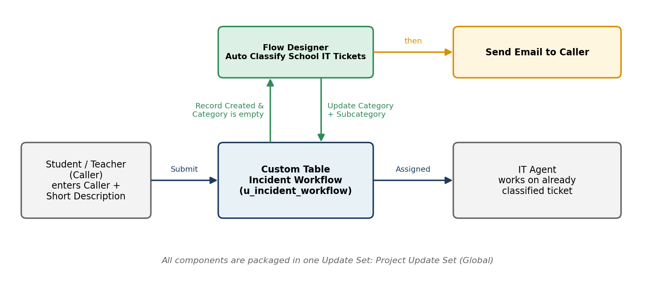
Figure 1.1 – Idea at a glance

8. Expected Benefits
- Less manual work for IT agents.
- Consistent and standardised ticket data.
- Faster routing and first response.
- Instant email acknowledgement improves caller experience.
- Simple to maintain and scale.

9. Assumptions and Constraints
- Callers write a meaningful short description (e.g. "WiFi not working in library").
- Only four common issue types are handled in this version.
- Classification is keyword-based (no machine learning).
- Developed and demonstrated on a ServiceNow Personal Developer Instance.

10. Tools & Technologies
ServiceNow PDI · Flow Designer (Workflow Studio) · Tables & Form Designer · Update Sets · Email notifications

